ACC-405
Module Seven Project Practice Problems and Solutions

Problem 1. Circus City issued an 8%, 10‐year $2,000,000 bond to build a monorail mass transit system. The city received $1,754,217 cash from the bond issuance on January 1, 2020. The bond yield is 10%. Interest is paid annually on December 31 of each year. Disclosure information about capital assets is reported below.

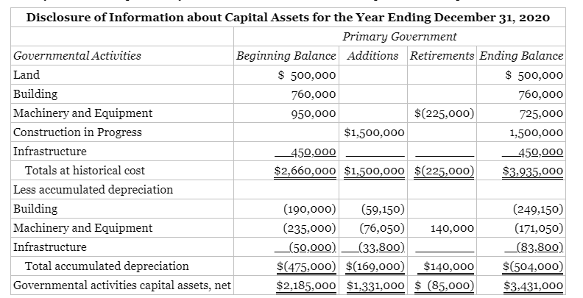

Depreciation expense charged to governmental activities as follows:

Public Safety $ 55,000
General Government 72,000
Highways and Streets 25,000
Sanitation 17,000
$169,000

Circus City's governmental funds financial statements are as follows:

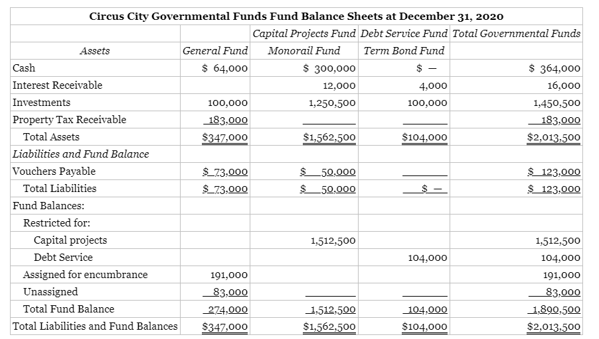

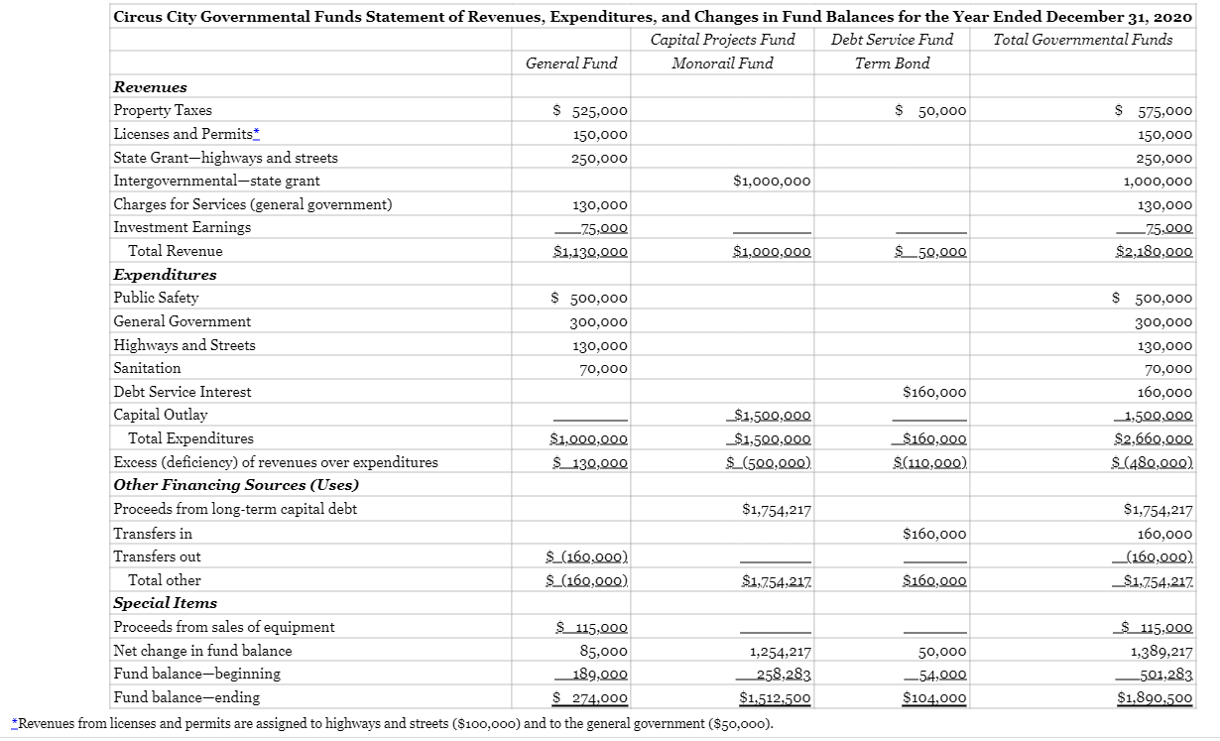

Required:
Using the information above, prepare the statement of activities and the statement of net position on a government‐wide basis (using full accrual accounting). The beginning fund balance in the government‐wide Statement of Net Position is $2,686,283.

Answer Circus City
Statement of Activites -Government-Wide
For the Year Ended December 31, 2020
 |  |  |  |  |  |  |  |  | Net (Expense) Revenue
 |  |  |  |  |  |  |  |  | and Changes in Net Position
 |  |  |  | Program Revenues |  |  |  |  | Primary Government
 |  |  |  | Charges for |  |  | Grants and |  | Governmental
Functions/Programs | Expenses (a) |  |  | Services |  |  | Contributions |  | Activities
Primary Government
Governmental Activities
Public Safety | $ 555,000 |  |  |  |  |  |  |  | $ (555,000)
General Government | 372,000 |  |  | $180,000 | (b) |  | $1,000,000 |  | 808,000
Highways and Streets | 155,000 |  |  | 100,000 | (b) |  | 250,000 |  | 195,000
Sanitation | 87,000 |  |  |  |  |  |  |  | (87,000)
Interest on long-term debt | 175,422 | (c) |  | _______ |  |  | _______ |  | (175,422)
Total governmental activities | 1,344,422 |  |  | 280,000 |  |  | 1,250,000 |  | 185,578
Total primary government | $ 1,344,422 |  |  | $ 280,000 |  |  | $ 1,250,000 |  | $ 185,578
 | General Revenues
 | Property taxes |  |  |  |  |  |  |  | $ 575,000
 | Investment earnings |  |  |  |  |  |  |  | 75,000
 | Special item - gain on sale of equipment |  |  |  |  |  |  |  | 30,000
 | Total general revenues, special items,
 | and transfers |  |  |  |  |  |  |  | $ 680,000
 | Change in net position |  |  |  |  |  |  |  | 865,578
 | Net position – beginning |  |  |  |  |  |  |  | 2,686,283
 | Net position - ending |  |  |  |  |  |  |  | $ 3,551,861
(a) Depreciation expense has been added to each governmental activity.
(b) Licenses and permits are charged $100,000 to highways and streets and $50,000 to general government.
(c) The debt amortization schedule is as follows (next page):

 | Interest expense |  | Cash paid |  | Discount |  | Carrying Value
Beginning balance |  |  |  |  |  |  | $1,754,217
12/31/20 | 175,422 |  | 160,000 |  | 15,422 |  | $1,769,639
12/31/21 | 176,964 |  | 160,000 |  | 16,964 |  | $1,786,603
12/31/22 | 178,660 |  | 160,000 |  | 18,660 |  | $1,805,263
12/31/23 | 180,526 |  | 160,000 |  | 20,526 |  | $1,825,790
12/31/24 | 182,579 |  | 160,000 |  | 22,579 |  | $1,848,369
12/31/25 | 184,837 |  | 160,000 |  | 24,837 |  | $1,873,205
12/31/26 | 187,321 |  | 160,000 |  | 27,321 |  | $1,900,526
12/31/27 | 190,053 |  | 160,000 |  | 30,053 |  | $1,930,579
12/31/28 | 193,058 |  | 160,000 |  | 33,058 |  | $1,963,637
12/31/29 | 196,363 |  | 160,000 |  | 36,363 |  | $2,000,000

 | Circus City
 | Statement of Net Position - Government-Wide Basis
 | At December 31, 2020
 |  |  |  |  |  | Statement
 |  |  |  |  |  | of Net Position
 |  |  |  |  |  | Total
 |  | Governmental |  |  |  | Government
 |  | Funds |  | Adjustments |  | Activities
 | Assets
 | Cash | $ 364,000 |  |  |  | $ 364,000
 | Interest Receivable | 16,000 |  |  |  | 16,000
 | Investments | 1,450,500 |  |  |  | 1,450,500
 | Receivables | 183,000 |  |  |  | 183,000
 | Capital Assets (net) | __________ |  | 3,431,000 |  | 3,431,000
 | Total Assets | 2,013,500 |  |  |  | $ 5,444,500
 | Liabilities and Fund Balance
 | Payables | $ 123,000 |  |  |  | $ 123,000
 | Long-term Liabilities | __________ |  | 1,769,639 |  | 1,769,639
 | Total Liabilities | $ 123,000 |  |  |  | $1,892,639
 | Net Position
 | Invested in Capital Assets, net of related debt |  |  |  |  | $ 1,661,361
 | Unrestricted | $ 1,786,500 |  |  |  | 1,786,500
 | Restricted for
 | Debt Service | 104,000 |  |  |  | 104,000
 | Total Fund Balance | 1,890,500 |  |  |  | 3,551,861
 | Total | $ 2,013,500 |  |  |  | $ 5,444,500

 | Reconciling the Statement of Net Position with Governmental Fund Reporting
 | Fund balance for governmental activities |  |  |  |  | $ 1,890,500
 | Capital assets used in governmental activities are not financial resources
 | and are not reported in the funds |  |  |  |  | 3,431,000
 | Long-term liabilities are not due and payable
 | in the current period and therefore are not reported in the funds. |  |  |  |  | (1,769,639)
 | Net Position in governmental activities |  |  |  |  | $ 3,551,861

Circus City
Reconciliation of the Statement of Revenues,
Expenditures, and Changes in Fund Balances of Governmental
Funds to the Statement of Activities
For the Year Ended December 31, 2020
 | Net change in fund balances - total governmental funds |  |  | $ 1,389,217
 | Governmental funds report capital outlays as expenditures while
 | governmental activities report depreciation expense to allocate those
 | expenditures over the life of the asset. This is the amount by which
 | capital outlays exceeded depreciation in the current period. |  |  | 1,331,000
 | In the statement of activities, only the gain on the sale of equipment
 | is reported, while in the governmental funds, the proceeds from the sale
 | increase financial resources. Thus, the change in net position differs
 | from the change in fund balance by the book value of the asset sold. |  |  | (85,000)
 | Bond proceeds provide current financial resources to governmental funds,
 | but issuing debt increases long-term liabilities in the statement of net
 | position. |  |  | (1,754,217)
 | Interest expense recognized on the accrual basis exceeds the amounts
 | paid by the amortization of the bond discount |  |  | (15,422)
 | Change in Net Position of Governmental Activities |  |  | $ 865,578

Problem 2.
Preston Library, a nonprofit organization, presented the following statement of financial position and statement of activities for its fiscal year ended February 28, 2019.

Preston Library
Statement of Financial Position
February 28, 2019
Assets | Unrestricted | Temporarily Restricted
Current Assets
Cash | $285,000 | $80,000
Grants Receivable | 80,000
Prepaid Expense | 65,000
Total | 430,000
Investments (at market) | 1,020,000
Land, Building, and Equipment (less Acc Dep of $50,000) | 530,000
Total Assets | $1,980,000 | 80,000
Liabilities and Fund Balances
Current Liabilities
Accounts Payable and Accrued Expenses | $150,000
Total | 150,000
Long-Term Debt | 200,000
Fund Balances | 1,630,000 | 80,000
Total Liabilities and Fund Balances | $1,980,000 | $80,000

Preston Library
Statement of Activities
for Year Ended February 28, 2019
Support and Revenue | Unrestricted | Temporarily Restricted
Support and Revenue
Grants | $ 70,000 | $ -
Gifts | 300,000 | 80,000
Total | 370,000 | 80,000
Revenue
Service Fees | 22,000
Book Rentals and Fines | 107,000
Investment Income | 71,000 | -
Total | 200,000
Total Support and Revenue | $ 570,000 | $ 80,000
Expenses
Program Services
Circulating Library | $ 212,000
Research Library | 86,000
Exhibits | 20,000
Community Services | 10,000
Total | 328,000 | 0
Supporting Services
General and Administrative | 175,000
Fund Raising | 111,000
Total | 286,000 | 0
Total Expenses | 614,000 | 0
Increase (decrease) in Net Assets | (44,000) | 80,000
Fund Balances - Beginning of Year | 1,674,000 | -
Fund Balances - End of Year | $ 1,630,000 | $ 80,000

The following transactions occurred during the fiscal year ended February 28, 2020.

- Fees were billed as follows:
Service fees $30,000
Book rentals 43,000
Book fines 78,000
- $40,000 of the Grant Receivable was received. Another grant in the amount of $20,000 was promised.
- Contributions in the amounts summarized below were received:
Unrestricted $215,000
Restricted 108,000
- Investment income totaled $75,000 for the year.
- Vouchers for the year were approved as follows:
Circulating library $189,000
Research library 74,000
Exhibits 15,000
Community services 12,000
General and administrative 166,000
Fund raising 103,000
Total $559,000
- During the year, $500,000 worth of vouchers were paid.

Adjustment Data

- Accounts Payable and Accrued Expenses at February 28, 2020, should be $217,000. The difference should be allocated to the following expenses:
Research library $5,000
General and administrative 3,000
- Additions to the research library in the amount of $68,000 that were approved in (5) above were made in accordance with the terms of a contribution that had been received earlier and that was restricted for that purpose.
- The current market value of the investments is $1,035,000 (no investment transactions occurred).
- Depreciation amounted to $9,000 for the year. It should be allocated as follows:
Circulating library $3,500
Research library 2,900
General and administrative 2,600
- Prepaid Expenses should be $60,000. The difference should be allocated to:
Exhibits $3,700
General and administrative 1,300

Required:
- Prepare journal entries to record the transactions
- Prepare the statement of financial position and the statement of activities for the year ended February 28, 2020.

Answer
 | Part A |  | 1. |  | Cash  Revenue - Service Fees  Revenue - Book Rentals & Fines |  | 151,000 |  | 30,000  121,000
 |  |  | 2. |  | Cash  Grant Receivable  Grant Receivable  Support – Grants |  | 40,000  20,000 |  | 40,000  20,000
 |  |  | 3. |  | Cash (Unrestricted)  Cash – Temporarily Restricted  Contributions – Gifts  Contributions – Restricted Support |  | 215,000  108,000 |  | 215,000  108,000
 |  |  | 4. |  | Cash  Investment Income |  | 75,000 |  | 75,000
 |  |  | 5. |  | Expenses - Circulating Library  Expenses - Research Library  Expenses - Exhibits  Expenses - Community Services  Expenses - General & Administrative  Expenses - Fund Raising  Accounts Payable |  | 189,000  74,000  15,000  12,000  166,000  103,000 |  | 559,000
 |  |  | 6. |  | Accounts Payable  Cash |  | 500,000 |  | 500,000
 |  |  | 7. |  | Expenses - Research Library  Expenses - General & Administrative  Accrued Expenses |  | 5,000  3,000 |  | 8,000
 |  |  | 8. |  | Net Assets Released from Restrictions  Cash – Temporarily Restricted  Cash – Unrestricted  Net Assets Released from Restrictions |  | 68,000  68,000 |  | 68,000  68,000
 |  |  | 9. |  | Investments  Investment Income |  | 15,000 |  | 15,000
 |  |  | 10. |  | Expenses - Circulating Library  Expenses - Research Library  Expenses - General & Administrative  Accumulated Depreciation |  | 3,500  2,900  2,600 |  | 9,000
 |  | 11. |  | Expenses - Exhibits  Expenses - General & Administrative  Prepaid Expenses |  | 3,700  1,300 |  | 5,000

Part B
PRESTON LIBRARY
Statement of Financial Position, February 28, 2020

Assets  Current Assets  Cash  Grants Receivable  Prepaid Expenses  Total  Investments (at market)  Land, Buildings, and Equipment  Less accumulated depreciation of $59,000  Total Assets  Liabilities and Fund Balances  Current Liabilities  Accounts Payable & Accrued Expenses  Total  Long-term Debt  Fund Balances  Total Liabilities and Fund Balances | Unrestricted  $334,000  60,000  60,000  454,000  1,035,000  521,000  $2,010,000  $ 217,000  217,000  200,000  1,593,000  $2,010,000 | Temporarily  Restricted  $120,000  ________  $120,000  120,000  $ 120,000

PRESTON LIBRARY
Statement of Activities
For Year Ended February 28, 2020
Support & Revenue  Support  Grants  Gifts  Total  Revenue  Service Fees  Book Rental & Fines  Investment Income  20-20  Total  Net Assets Released from Restrictions  Total Revenue, Gains and Other Support  Expenses  Program Services  Circulating Library  Research Library  Exhibits  Community Services  Total  Support Services  General & Administrative  Fund Raising  Total  Total  Increase (decrease) in Net Assets  Fund Balances – Beginning of Year  Fund Balances – End of Year | Without  Donor  Restrictions  $20,000  215,000  235,000  30,000  121,000  90,000  241,000  68,000  $544,000  $192,500  81,900  18,700  12,000  305,100  172,900  103,000  275,900  $ 581,000  ($37,000)  1,630,000  $1,593,000 | With donor  Restrictions  108,000  108,000  (68,000)  40,000  40,000  80,000  $ 120,000

Problem 3. The partnership of Cain, Gallo, and Hamm engaged you to adjust its accounting records and convert them uniformly to the accrual basis in anticipation of admitting Kerns as a new partner. Some accounts are on the accrual basis and some are on the cash basis. The partnership's books were closed at December 31, 2019, by the bookkeeper, who prepared the general ledger trial balance that appears as follows:

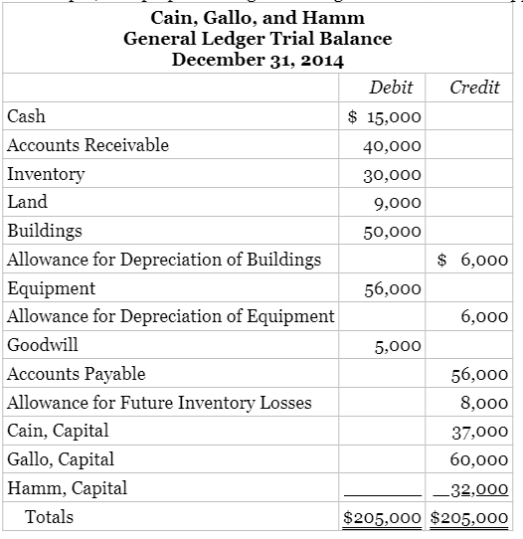

Your inquiries disclose the following:

- The partnership was organized on January 1, 2018. No provision was made in the partnership agreement for the allocation of partnership profits and losses. During 2018, profits were allocated equally among the partners. The partnership agreement was amended, effective January 1, 2019, to provide for the following profit and loss ratio: Cain, 40%; Gallo, 40%; and Hamm, 20%. The amended partnership agreement also stated that the accounting records were to be maintained on the accrual basis and that any adjustments necessary for 2018 should be allocated according to the 2019 profit allocation agreement.
- The following amounts were not recorded as prepayments or accruals.
December 31 2019 2018
Prepaid insurance $700 $ 800
Advances from customers 900 1,500
Accrued interest expense — 450

The advances from customers were recorded as sales in the year the cash was received.
- In 2019, the partnership recorded a provision of $8,000 for anticipated declines in inventory prices. You convinced the partners that the provision was unnecessary and should be removed from the books.
- The partnership charged equipment purchased for $4,400 on January 1, 2019, to expense. This equipment has an estimated life of 10 years and an estimated salvage value of $400. The partnership depreciates its capitalized equipment using the declining balance method at twice the straight‐line depreciation rate.
- The partners agreed to establish an allowance for doubtful accounts at 2% of current accounts receivable and 5% of past‐due accounts. At December 31, 2018, the partnership had $54,000 of accounts receivable, of which only $4,000 was past due. At December 31, 2019, 20% of accounts receivable was past due, of which $4,000 represented sales made in 2018 and was considered collectible. The partnership had written off uncollectible accounts in the year the accounts became worthless as follows:
Accounts Written Off In 2019 2018
2019 accounts $ 800 —
2018 accounts 1,000 $250

- Goodwill was recorded on the books in 2019 and credited to the partners' capital accounts in the profit and loss ratio in recognition of an increase in the value of the business resulting from improved sales volume. The partners agreed to write off the goodwill before admitting the new partner.

Required:
Prepare a worksheet showing the adjustments and the adjusted trial balance for the partnership on the accrual basis at December 31, 2019. All adjustments affecting income should be made directly to partners' capital accounts. Supporting computations should be in good form. (Do not prepare formal financial statements or formal journal entries.)

Answer
Adjustments to Adjustments To
2018 Income 2019 Income

2. Prepaid insurance expensed in 2018 $800 $(800)a
Prepaid insurance expensed in 2019 --- 700
Advances from customers in 2018 (1,500) 1,500b
Advances from customers in 2019 --- (900)
Accrued interest expense (450) 450c
3. Add back provision for inventory decline 8,000

4. Add back purchase price of equipment expensed
less depreciation expense of $880 3,520d
5. Deduct (add) adjustment to allowance account (1,200) 160e
6. Deduct goodwill recognized (5,000)
Total adjustment to capital accounts $(2,350) $7,630

aThis assumes that the prepaid insurance expires in the next year.
bThis assumes that the advances are earned in the next year.
cThis assumes that the interest expense was deducted in 2019.
dDepreciation expense = $4,400 × 0.20 = $880
2018 2019
e2% of current receivables (0.02 × $50,000) $1,000 (0.02 × $32,000) $640
5% of past due receivables (0.05 × $4,000) 200 (0.05 × $8,000) 400
Allowance account balance at 12/31 $1,200 $1,040

Allowance for Bad Debts
Write-off-2019 1,800 | 1/1 1,200
 | Adjustment 1,640
 | 12/31 Bal. 1,040

During 2019, $1,800 was written off and debited to expense
Adjustment to income is $160 or ($1,800 - $1,640)

Analysis of Change in Capital Accounts

2018 Adjustment 2019 Adjustment Total
Cain 1/3 $(783) 0.40 $3,052 $2,269
Gallo 1/3 (783) 0.40 3,052 2,269
Hamm 1/3 (784) 0.20 1,526 742
$(2,350)* $7,630 $5,280

*Number is rounded:

Cain, Gallo, and Hamm Partnership
Adjusted Trial Balance
December 31, 2019

Unadjusted Adjusted
Balance Adjustment Balance 12/31/2019
Dr. Cr. Dr Cr Dr. Cr.
Cash $15,000 $15,000
Accounts Receivable 40,000 40,000
Inventory 30,000 30,000
Land 9,000 9,000
Buildings 50,000 50,000
Allowance for Depreciation of Buildings 6,000 6,000
Equipment 56,000 4,400 60,400
Allowance for Depreciation of Equipment 6,000 880 6,880
Goodwill 5,000 5,000
Accounts Payable 56,000 56,000
Allowance for Future Inventory Losses 8,000 8,000
Cain, Capital 37,000 2,269 39,269
Gallo, Capital 60,000 2,269 62,269
Hamm, Capital 32,000 742 32,742
Prepaid Insurance 700 700
Advances from Customers 900 900
Allowance for Doubtful Accounts _______ _______ ______ 1,040 _______ 1,040
$205,000 $205,000 $13,100 $13,100 $205,100 $205,100

