**Module Four Assignment**

Evelyn M. Smith

Southern New Hampshire University

BUS 225: Critical Business Skills for Success

Anna Harrison

November 24, 2024

# Module Four Assignment

## Explanation of the Importance of Data Analysis

I believe data analysis is important for determining the success of a new product launch. By getting key metrics such as sales volume, revenue, costs, and profit margins, I can evaluate if the product is achieving its financial goals. According to the data (Southern New Hampshire University (n.d.), I am reporting on various factors like labor costs, materials, overhead, and profit margins, as well as units produced and sold. It is important to analyze the relationship between the units sold and target revenue, as well as profitability trends over time. Through this analysis, I can identify whether the product is gaining traction and if sales are meeting expectations. I also look at profit margins and overhead to assess whether the company is operating efficiently. Analyzing this information allows me to adjust strategies, such as production or marketing, to ensure the product's success. I believe data analysis provides valuable insights that help guide decision-making and optimize future performance (BFI, 2024).

## Description of Findings

The company faced challenges early in the year, as the total revenue initially fell short of covering costs, leading to a massive downfall at the beginning of the year. For example, in Jan and Feb, the company experienced negative profit margins, with losses of $18,920 and $16,420, respectively. However, as the year went by, there was noticeable progress in sales, especially from May onwards, with revenues climbing steadily. By mid-year, the company began to see positive profits, particularly in the months of July to December, with profits consistently around $12,905. Despite these gains, the business was still unable to fully meet its target profit of 25%, as evidenced by the final annual profit of $9,830, which equates to a profit margin of only 4.18% (Southern New Hampshire University (n.d.). This suggests that while the product showed growth in sales, it did not fully achieve the targeted profitability. To find out if the product met expectations, I used key data points such as the total revenue, cost of goods sold, and profit margins. I compared these with the target revenue and profit goals to see if the product was on track. The analysis of the sales numbers and profitability trends indicated that while the product gained traction in the second half of the year, it still fell short of meeting the desired financial outcomes. Therefore, while the product was successful, improvements are needed to fully meet the profit goal.

## Summary of Results

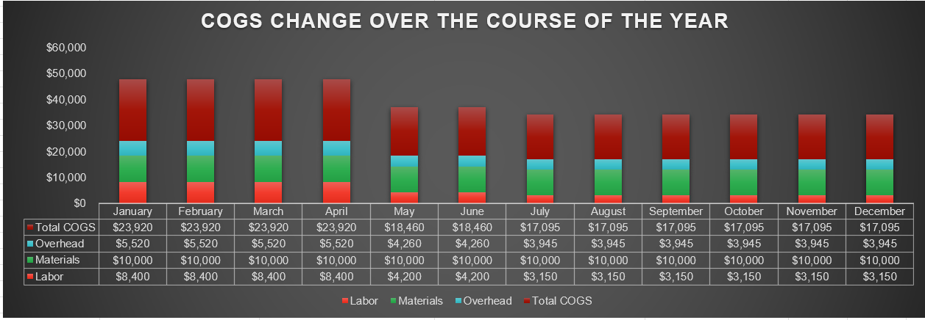

This stacked bar chart will show the total COGS for each month, with the Labor, Materials, and Overhead components stacked on top of each other (CDATA, 2024). This allows you to see how the different cost components contribute to the total cost of goods sold each month.

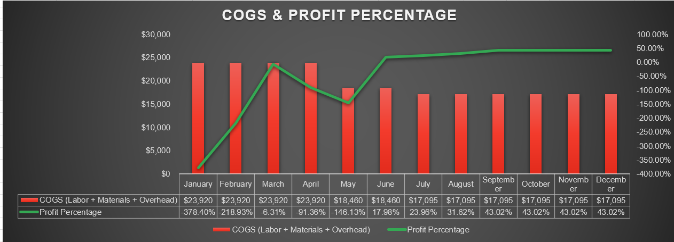

This is a Combo Chart that combines a bar chart and a line chart. The bar chart shows the Cost of Goods Sold (COGS), while the line chart tracks Profit Percentage. It provides information on how costs changed throughout the year and how profitability improved, indicating the success of the product launch.

I used data visualizations, including a Combo Chart (Bar + Line) and a Stacked Bar Chart, to show an accurate information into how the costs and profits evolved month-to-month. From the Combo Chart, I observed that the profit percentage fluctuated significantly, reaching a peak in the later months, which corresponded with a steady decline in COGS. The Stacked Bar Chart showed that Labor, Materials, and Overhead all contributed to the fluctuations in total COGS, with Labor and Overhead seeing the most noticeable reductions as the year progressed (BFI, 2024).

## References

Soomo Learning. (2020). Critical business skills for success. p4.2. p4.3. <https://www.webtexts.com>

Southern New Hampshire University. (n.d.). Business 225 Cost Revenue and Profit. Excel. Brightspace. <https://learn.snhu.edu/d2l/lp/auth/saml/login>

CDATA Software, (2024, February 9). The Importance of Data Analysis: An Overview of Data Analytics. <https://www.cdata.com/blog/importance-of-data-analysis>

BFI Insights. (2024). The Importance of data analysis in today’s Business World. <https://bfiinsights.com/the-importance-of-data-analysis-in-todays-business-world/>