**Module One Assignment**

Evelyn Smith

Southern New Hampshire University

BUS 400: 1-2 Blog: Project Analysis

Tyler Smith

November 1, 2024

# Module One Assignment

## Innovating for the Future: A New Service Offering from Markel Group Inc.

Have you ever wondered how an established company can stay ahead in the competitive insurance landscape? As the newly appointed Chief Innovation Officer (CIO) of Markel Group Inc., I’m excited to explore innovative solutions that will enhance our offerings in North America. Based in Richmond, Virginia, Markel is recognized for its diverse insurance and investment services, particularly in specialty insurance lines. Today, I want to introduce a unique new service that aligns with our core competencies and addresses the evolving needs of our clients.

## Company Overview

Markel Group Inc. primarily operates in the specialty insurance sector, providing coverage for areas such as property, casualty, and professional liability. Our North American operations are centered in Richmond, with regional offices across the United States and Canada. This extensive network enables us to serve a wide range of clients, from small businesses to large institutions.

## Value Proposition

Markel’s main business revolves around delivering high-quality specialty insurance products tailored to unique risks faced by our clients. Our value lies in our deep understanding of niche markets and our commitment to providing customized solutions that meet the specific needs of policyholders.

**Profitability**

Markel has consistently demonstrated strong profitability. According to the latest financial reports, the company has shown steady revenue growth, reflecting robust demand for our insurance products. This financial health positions us well to invest in new initiatives that can further enhance profitability.

**SWOT Analysis**

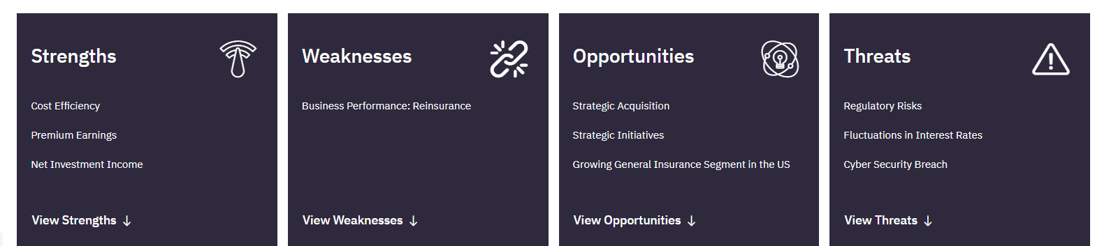

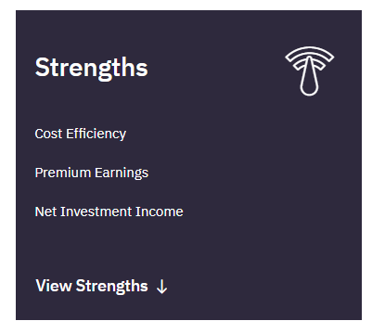

* **Strengths:**

**Cost Efficiency**

The company reported an improvement in cost efficiency in FY2023. Its operating expenses as a percentage of revenue improved to 81.47% in FY2023 from 100.8% in FY2022. This was due to an increase of 35.4% in revenue to US$15,803.4 million from US$11,675.3 million in the previous year. Growth in revenue was due to increase net investment income, products revenue, and earned premiums. Its operating income grew to US$2,928.8 million from loss of US$93.3 million in the previous year (GlobalData, 2024).

**Operational |Premium Earnings**

The company reported increase in premium earnings, which indicates rise in demand for its offerings. Its premium earned increased 9%, to US$8,295.5 million in FY2023 from US$7,587.8 million in FY2022. The increase in premium earned was due to higher gross premium volume from its insurance segment driven by more favorable rates and growth in new business from all the product lines (GlobalData, 2024).

**Financial |Net Investment Income**

The company reported growth in its net investment income in FY2023, which enhanced its ability to meet policy claims. During the year, the company’s net investment income increased to US$734.5 million from US$446.8 million in FY2022. The growth was driven by higher interest income on fixed maturity securities, cash equivalents, and short-term investments was achieved due to increased yields compared to the previous year. The rise in short-term interest rates resulted in an increase in cash allocation to money market funds, while higher holdings of fixed maturity securities strengthened interest income (GlobalData, 2024).

Access the complete report here: [SWOT - GlobalData Intelligence Center - Explorer](https://explorer.globaldata.com/Company/Swot/markel_corporation?swot)

**New Product/Service Concept**

**Introducing the Markel Risk Advisory Service**

To leverage our strengths and meet the evolving needs of our clients, I propose the launch of the Markel Risk Advisory Service. This innovative service will provide businesses with customized risk assessments and management strategies tailored to their unique industry challenges.

**Product/Service Singularity**

What sets the Markel Risk Advisory Service apart is its proactive, data-driven approach. Unlike traditional insurance offerings, this service will focus on risk mitigation strategies before potential losses occur. Clients will receive detailed reports, actionable insights, and ongoing support, ensuring that their risk management practices align with best industry standards.

**New Product/Service Projections**

The introduction of the Markel Risk Advisory Service is expected to improve profitability in several ways:

* **Recurring Revenue Stream:** By offering subscription-based advisory services, we can establish a predictable revenue stream, enhancing financial stability.
* **Enhanced Client Relationships:** Tailored risk solutions will strengthen client loyalty and retention, increasing their lifetime value.
* **Cross-Selling Opportunities:** Clients engaged in advisory services may be more inclined to purchase additional insurance products, boosting overall sales.
* **Market Differentiation:** This unique offering will set us apart in the insurance landscape, attracting new clients and increasing our market share.

**Conclusion**

In conclusion, the Markel Risk Advisory Service is an exciting opportunity for Markel Group Inc. to enhance our offerings and better serve our clients. By focusing on proactive, data-driven solutions tailored to the unique needs of businesses, we can not only drive profitability but also strengthen our position as a trusted leader in the insurance sector.

I’d love to hear your thoughts on this new service! What features or enhancements do you think could make it even more valuable for our clients? Your feedback is essential as we strive to meet and exceed their expectations. Please share your ideas in the comments below!

# References

Markel Group Inc. (2023). Annual report. [Markel Group reports 2023 financial results](https://www.markel.com/about-us/news-and-press/markel-group-reports-2023-financial-results-122804)

Markel. (2024). Our Story. [Our Story | Markel Group (mklgroup.com)](https://www.mklgroup.com/who-we-are/our-story)

Markel. (2024). Markel is a global specialty insurance provider with a truly people-first approach. [Specialty Insurance | Markel](https://www.markel.com/)

Global Data. (2024). Markel Group Inc - Company Profile. <https://www.globaldata.com/company-profile/markel-corp/swot-analysis/>

GlobalData. (2024, October 10). Markel Group Inc |SWOT. <https://explorer.globaldata.com/Company/Swot/markel_corporation?swot>

Sec.gov. (2024). United States Securities and Exchange Commission Form 10-K. Markel Group Inc. p-10K-F317. [mkl-20231231 (sec.gov)](https://www.sec.gov/Archives/edgar/data/1096343/000109634324000025/mkl-20231231.htm)

Sec.gov. (2024, 2023, 2022, 2021, 2020). United States Securities and Exchange Commission Form 10-K. Markel Group Inc. Consolidated Balance Sheets. [mkl-20231231 (sec.gov)](https://www.sec.gov/Archives/edgar/data/1096343/000109634324000025/mkl-20231231.htm)

Sec.gov. (2024, 2023, 2022, 2021, 2020). United States Securities and Exchange Commission Form 10-K. Markel Group Inc. Consolidated Statement of Income. [mkl-20231231 (sec.gov)](https://www.sec.gov/Archives/edgar/data/1096343/000109634324000025/mkl-20231231.htm)

Sec.gov. (2024, 2023, 2022, 2021, 2020). United States Securities and Exchange Commission Form 10-K. Markel Group Inc. Consolidated Statement of Cashflows. [mkl-20231231 (sec.gov)](https://www.sec.gov/Archives/edgar/data/1096343/000109634324000025/mkl-20231231.htm)